Final Year Design Project System Requirements Specification
AI-Powered Smart Road Visibility & Hazard Detection System
______________________________________

Software Design Specification Document

by

Zartasha Ansari | BCS22001
Isba Sohail | BCS22003
Noor-E- Hira | BCS22018
Ifra Kashif | BCS22020

Project Advisor:

Department of Information Technology
University of the Punjab, Gujranwala Campus, Gujranwala, Pakistan
(2026)
AI-Powered Smart Road Visibility & Hazard Detection System

Executive Summary:
This Software Design Specification (SDS) documents the architectural blueprint for the AI-Powered Smart Road Visibility & Hazard Detection System. Following the requirements established in the System Requirements Specification (SRS), this document details the transformation of the system requirements into a modular, structural design. The system is architected as a standalone Desktop Application optimized for real-time performance on consumer-grade hardware.
The design strategy adopts a Layered Architecture pattern, strictly separating concerns into four distinct layers: Presentation, Application Logic, AI Processing, and Data/Hardware. This modular approach ensures that the computationally heavy AI tasks (YOLOv8 inference) remain isolated from the User Interface, ensuring responsiveness. Key design decisions include the use of the YOLOv8 Nano model for high-speed detection, SQLite for offline data persistence, and OpenCV for contrast-based visibility estimation. This document outlines the interfaces and data structures necessary to achieve the safety-critical goal of <200ms latency and 15–30 FPS performance.

Table of Contents

Executive Summary: 2
System Design: 5
1. Design Considerations: 5
1.1. Assumptions and Dependencies: 5
1.2. Limitations: 6
1.3. Risks: 6
2. Requirements Traceability Matrix: 6
3. Design Models: 7
3.1. Architectural Design: 7
3.1.1. UML Component Diagarm: 8
3.1.2. UML class Relationship Diagram: 9
3.2. Data Design: 11
3.2.1. Database Entities(Tables): 11
3.2.2. Data Dictionary: 15
3.3. User Interface Design: 19
3.3.1. Screen Images: 19
3.3.2. Screen Objects and Actions: 19
3.4. Behavioral Model: 19
3.4.1. Interaction Diagram: 19
3.4.2. State Transition Diagaram: 20
4. Design Decisions: 21
4.1. Selection of AI Architecture: YOLOv8 Nano 21
4.2. Database Selection: SQLite 21
4.3. Visibility Algorithm: Contrast-Based Analysis 21
4.4. Selection of Programming Language: Python 22
4.5. Deployment Architecture: Standalone Desktop Application 22
5. Summary: 23
References 23

List of Tables

Table 1 : Requirements Traceability Matrix 7
Table 2 : UML Class-Relationship Table 11
Table 3 : Entity 1: Users 12
Table 4 : Entity 2: TripSessions 12
Table 5 : Entity 3: HazardEvents 13
Table 6 : Data Dictionary Table 18

List of Figures

Figure 1 : UML Component Diagarm 8
Figure 2 : UML Class-Relationship Diagram 9
Figure 3 : ER Diagram 14
Figure 4 : Interaction Diagarm 19
Figure 5 : State Diagram 20

System Design:
Product Perspective
The system functions as an intelligent intermediary layer between the vehicle's environment and the driver. It operates locally on Windows 10/11 or Linux systems, interacting directly with hardware peripherals via the Data/Hardware Layer.
- Hardware Interaction: It captures video via the CameraHandler interface (using DirectShow/V4L2) and issues audio warnings via the host's system drivers.
- Offline Capability: The system relies on a local SQLite database, ensuring full functionality without internet connectivity.
Design Constraints
The architecture adheres to strict performance boundaries to ensure driver safety:
- Latency Constraint: The AlertSystem and YOLODetector must complete the processing loop (Capture -> Detect -> Alert) in under 200 milliseconds.
- Hardware Constraint: The system is optimized for standard laptops (Core i5, 8GB RAM). It utilizes the YOLOv8 Nano model to run efficiently on CPUs without requiring dedicated GPUs.
- Resolution Constraint: Video input is constrained to 640x480 (VGA) to maximize frame processing speed.

Design Considerations:

Assumptions and Dependencies:
- Assumption: The user's hardware includes a functional webcam or dashcam recognized by the OS as index 0 or 1.
- Dependency: The system requires the Ultralytics YOLOv8 library and the specific yolov8n.pt model weights file to be present in the installation directory.
- Dependency: The application depends on Python 3.8+ and OpenCV for the ImageProcessor module functions.

Limitations:
- Contrast-Based Visibility: As defined in the Design Decisions, visibility is calculated using contrast analysis rather than depth sensors. This is highly effective for smog but does not provide absolute distance measurements in meters.
- Night Performance: While the SettingsManager supports "Dark Mode," detection accuracy relies on the camera's ISO sensitivity in low-light conditions.

Risks:
- Risk: System Lag on Older CPUs.
  - Mitigation: The AI Processing Layer is decoupled from the Presentation Layer. If inference slows down, the GUI will continue to render the latest available frame rather than freezing.
- Risk: Database Corruption.
  - Mitigation: The DatabaseManager utilizes SQLite's atomic transaction integrity to prevent data loss if the laptop shuts down unexpectedly during a trip.

Requirements Traceability Matrix:
Requirement ID | Requirement Description | Design Specification (Component Mapping)
FR-1 | User Login and Session Management. | Component: AuthenticationManager (verifies via DatabaseManager)
FR-2 | Real-Time Video Dehazing and Display. | Component: ImageProcessor (Methods: dehaze_frame, adjust_contrast)
FR-3 | Real-Time Visibility Scoring (Good/Critical). | Component: VisibilityEstimator (Method: calculate_score)
FR-4 | Low-Contrast Obstacle Detection. | Component: YOLODetector (Method: detect_objects)
FR-5 | UI Customization (Dark Mode/Fonts). | Component: SettingsManager (Attributes: current_settings)
FR-6 | Trip Data Logging (History/CSV). | Component: DatabaseManager (Methods: log_trip_event, export_to_csv)
FR-7 | Audio Alert & Voice Tone Customization. | Component: AlertSystem (Attributes: audio_engine)
Table 1: Requirements Traceability Matrix

Design Models:

Architectural Design:
The system utilizes a Layered Architecture. This pattern was chosen to ensure modularity and separation of concerns, allowing the AI components to be upgraded independently of the User Interface.

UML Component Diagarm:
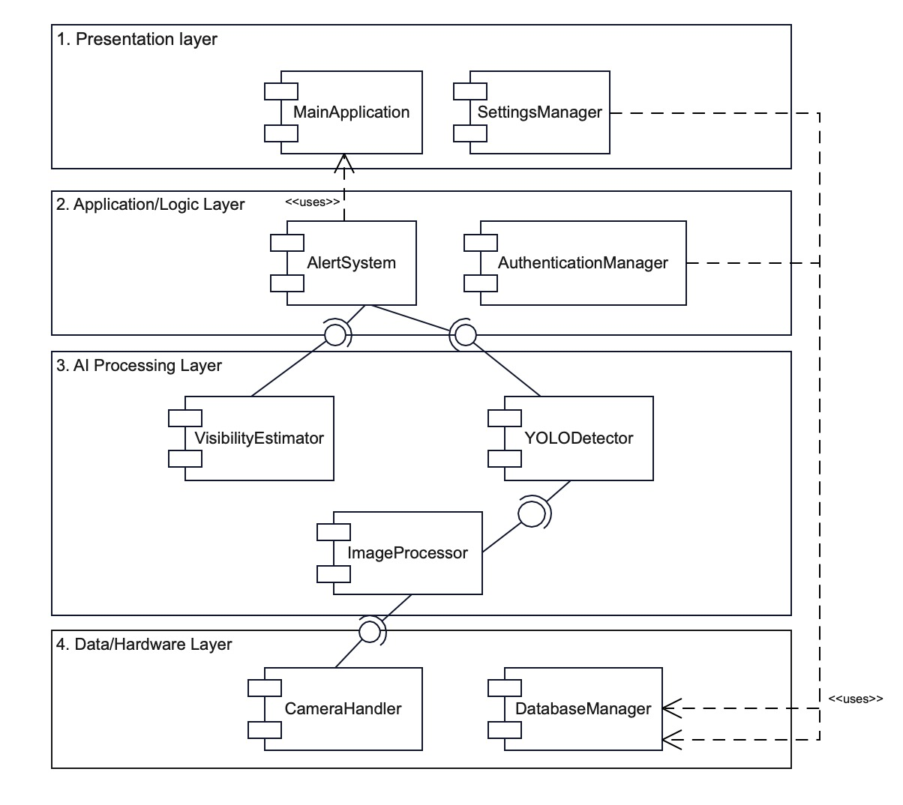
Figure 1: UML Component Diagarm

Description:
- Presentation Layer:
  - Components: MainApplication, SettingsManager.
  - Responsibility: Manages the GUI lifecycle, captures user inputs, and displays the processed video feed. It communicates only with the Application Layer.
- Application / Logic Layer:
  - Components: AlertSystem, AuthenticationManager.
  - Responsibility: Acts as the controller. It enforces business logic (e.g., verifying passwords, deciding when to trigger an alert based on thresholds).
- AI Processing Layer:
  - Components: YOLODetector, VisibilityEstimator, ImageProcessor.
  - Responsibility: The computational core. It receives raw frames and returns structured data (object lists, visibility scores) to the Logic Layer.
- Data / Hardware Layer:
  - Components: CameraHandler, DatabaseManager.
  - Responsibility: Abstracts the low-level details of hardware interactions (webcam drivers) and persistent storage (SQL queries).

UML class Relationship Diagram:
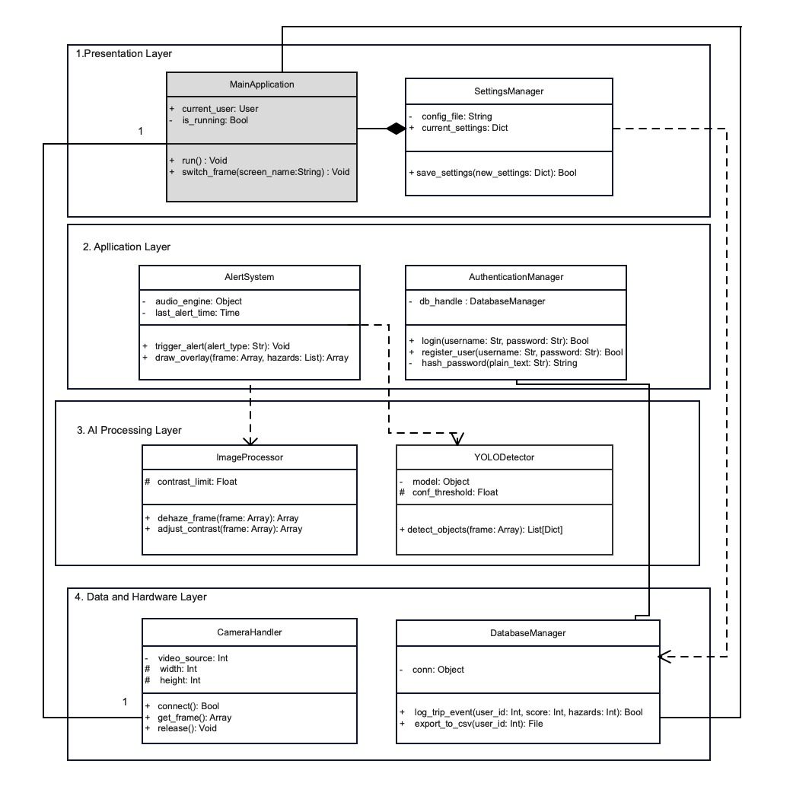
Figure 2: UML Class-Relationship Diagram

Layer | Component / Class | Technical Responsibility & Mapping
1. Presentation Layer | MainApplication | The central controller managing the GUI lifecycle and transitions between Login, Dashboard, and Settings screens.
1. Presentation Layer | SettingsManager | Handles user-specific configurations such as UI themes and audio preferences stored in JSON format.
2. Application Layer | AlertSystem | Interacts with the AI engine to trigger real-time audio warnings and draw visual bounding box overlays on the video feed.
2. Application Layer | AuthenticationManager | Manages security protocols, including SHA-256 password hashing and session validation against the user database.
3. AI Processing Layer | YOLODetector | Executes the YOLOv8 Nano inference engine to detect obstacles with high confidence under low-visibility conditions.
3. AI Processing Layer | ImageProcessor | Performs dark channel prior (DCP) dehazing and contrast adjustments to improve visibility for the detection engine.
3. AI Processing Layer | VisibilityEstimator | Analyzes image density to calculate a real-time visibility score (0-100) for the driver's HUD.
4. Data & Hardware Layer | CameraHandler | Manages the physical hardware interface with the dashcam/webcam via OpenCV at a targeted 15–30 FPS.
4. Data & Hardware Layer | DatabaseManager | Handles all persistent storage operations, executing SQL queries to log trip data and hazard events into SQLite

Table 2: UML Class-Relationship Table

Data Design:
The system information domain is transformed into a persistent storage format using a Relational Database Management System (RDBMS). Specifically, the system utilizes SQLite as the database engine. This choice ensures that all data (user credentials, logs, and settings) is stored locally on the user's machine in a single .db file, providing offline reliability and zero-latency access during driving sessions.
The data design follows the Third Normal Form (3NF) to ensure data integrity and minimize redundancy.

Database Entities(Tables):
The system comprises three primary entities: Users, TripSessions, and HazardEvents. The structure and constraints for each are defined below:
- Users:
This entity stores the authentication credentials and personalization settings for each driver.
Attribute | Data Type | Key Type | Description
user_id | INTEGER | PK | Unique identifier for the user (Auto-incremented).
username | TEXT | Unique | The login username selected by the driver.
password_hash | TEXT |  | The SHA-256 encrypted password string (Raw passwords are never stored).
created_at | DATETIME |  | Timestamp of account creation.
preferences | TEXT |  | A JSON-formatted string storing UI settings (e.g., {'theme': 'dark', 'audio': 'male'}).

Table 3: Entity 1: Users
- TripSessions:
Attribute | Data Type | Key Type | Description
session_id | INTEGER | PK | Unique identifier for the trip.
user_id | INTEGER | FK | Foreign Key linking to the Users table (Users.user_id).
start_time | DATETIME |  | Timestamp when the "Start Trip" button was clicked.
end_time | DATETIME |  | Timestamp when the trip was ended.
avg_visibility | REAL |  | The average visibility score (0-100) calculated for the entire trip.
total_hazards | INTEGER |  | Counter for the total number of hazards detected during the trip.
This entity represents a single continuous driving period. It links the driving data to a specific User.
Table 4: Entity 2: TripSessions
- HazardEvents:
This entity logs specific safety incidents. It allows the system to reconstruct when and why alerts were triggered.
Attribute | Data Type | Key Type | Description
event_id | INTEGER | PK | Unique identifier for the specific event.
session_id | INTEGER | FK | Foreign Key linking to TripSessions (TripSessions.session_id).
timestamp | DATETIME |  | Exact time the hazard occurred.
type | TEXT |  | The classification of the event (e.g., "Critical Visibility", "Pedestrian", "Vehicle").
confidence | REAL |  | The confidence score (0.0 - 1.0) provided by the YOLOv8 model (if applicable).
gps_lat | REAL |  | (Optional) Latitude coordinate of the event.
gps_long | REAL |  | (Optional) Longitude coordinate of the event.
Table 5: Entity 3: HazardEvents

ER Diagram(ERD):
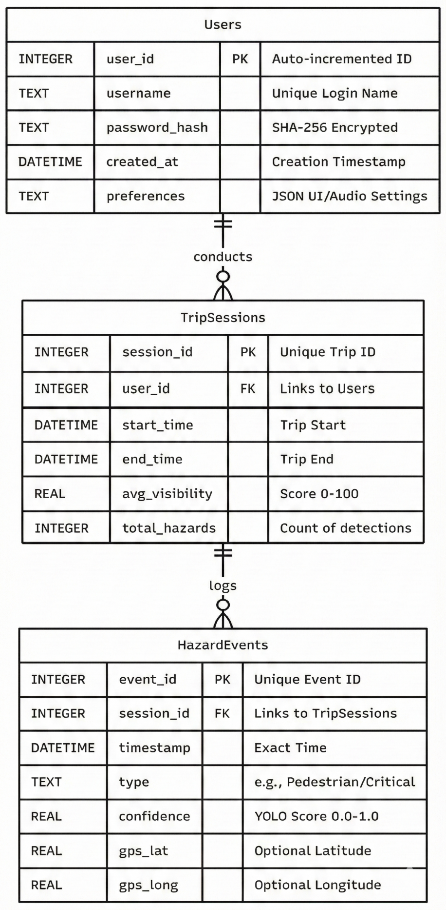

Figure 3: ER Diagram

Data Dictionary:
Object / Class Name | Type | Description & Responsibilities
MainApplication | Class | The Controller. It manages the application lifecycle, switching between the Login Screen, Dashboard, and Settings.
current_user | Attribute (User) | Stores the User object of the currently logged-in driver.
is_running | Attribute (Bool) | Flag to control the main application loop (True/False).
run() | Method | Params: None.  Returns: Void.  The entry point that launches the GUI window.
switch_frame() | Method | Params: screen_name (String).  Returns: Void.  Hides the current view and displays the requested screen (e.g., "Dashboard").
AuthenticationManager | Class | Security Handler. Manages user login, registration, and session security.
db_handle | Attribute (Obj) | Reference to the DatabaseManager instance.
login() | Method | Params: username (Str), password (Str).  Returns: Bool.  Hashes the password and checks it against the database. Returns True if valid.
register_user() | Method | Params: username (Str), password (Str), email (Str).  Returns: Bool.  Creates a new user record in the database.
hash_password() | Method | Params: plain_text (Str).  Returns: String.  Converts a plain password into a secure SHA-256 hash string.
CameraHandler | Class | Hardware Interface. Manages the connection to the webcam or dashcam.
video_source | Attribute (Int) | The ID of the camera (0 for webcam, 1 for USB).
width | Attribute (Int) | Frame width constraint (e.g., 640px).
height | Attribute (Int) | Frame height constraint (e.g., 480px).
connect() | Method | Params: None.  Returns: Bool.  Attempts to open the video stream via OpenCV cv2.VideoCapture.
get_frame() | Method | Params: None.  Returns: Numpy Array (Image).  Reads the latest frame from the hardware buffer.
release() | Method | Params: None.  Returns: Void.  Frees the camera resource when the app closes.
ImageProcessor | Class | Enhancement Engine. Handles the "Dehazing" feature.
contrast_limit | Attribute (Float) | The CLAHE limit applied to the image (default 2.0).
dehaze_frame() | Method | Params: frame (Numpy Array).  Returns: Numpy Array.  Applies Dark Channel Prior (DCP) algorithm to remove fog artifacts.
adjust_contrast() | Method | Params: frame (Numpy Array).  Returns: Numpy Array.  Enhances visibility by stretching the histogram of the image.
VisibilityEstimator | Class | Analysis Engine. Calculates the "Visibility Score".
history_buffer | Attribute (List) | Stores the last 30 scores to smooth out flickering.
calculate_score() | Method | Params: frame (Numpy Array).  Returns: Integer (0-100).  Analyzes image density to produce a visibility percentage.
get_status_label() | Method | Params: score (Int).  Returns: String.  Maps the score to text: "GOOD" (>70), "MODERATE" (40-70), "CRITICAL" (<40).
YOLODetector | Class | AI Engine. Wrapper for the Ultralytics YOLOv8 model.
model | Attribute (Obj) | The loaded PyTorch model instance (yolov8n.pt).
conf_threshold | Attribute (Float) | Minimum confidence required to detect a car (e.g., 0.50).
detect_objects() | Method | Params: frame (Numpy Array).  Returns: List[Dictionaries].  Runs inference. Returns a list of detected objects: {'class': 'Car', 'box': [x,y,w,h], 'conf': 0.85}.
AlertSystem | Class | Feedback Handler. Manages audio and visual warnings7.
audio_engine | Attribute (Obj) | Instance of pyttsx3 text-to-speech engine.
last_alert_time | Attribute (Time) | Timestamp of the last warning (to prevent spamming).
trigger_alert() | Method | Params: alert_type (Str).  Returns: Void/  Plays the specific sound (e.g., "Obstacle Ahead") based on the type.
draw_overlay() | Method | Params: frame (Numpy Array), hazards (List).  Returns: Numpy Array.  Draws the red bounding boxes and warning text onto the video frame.
SettingsManager | Class | Config Handler. Stores user preferences8.
config_file | Attribute (Str) | Path to the config.json file.
current_settings | Attribute (Dict) | Stores values like {'theme': 'dark', 'font_size': 14, 'voice': 'female'}.
save_settings() | Method | Params: new_settings (Dict).  Returns: Bool.  Writes the updated preferences to the JSON file.
DatabaseManager | Class | Data Handler. Manages SQLite interactions for logs9.
conn | Attribute (Obj) | The active SQLite connection object.
log_trip_event() | Method | Params: user_id (Int), score (Int), hazards (Int).  Returns: Bool.  Inserts a new row into the TripLogs table.
export_to_csv() | Method | Params: user_id (Int).  Returns: File.  Queries all logs for a user and writes them to a .CSV file.

Table 6: Data Dictionary Table

User Interface Design:

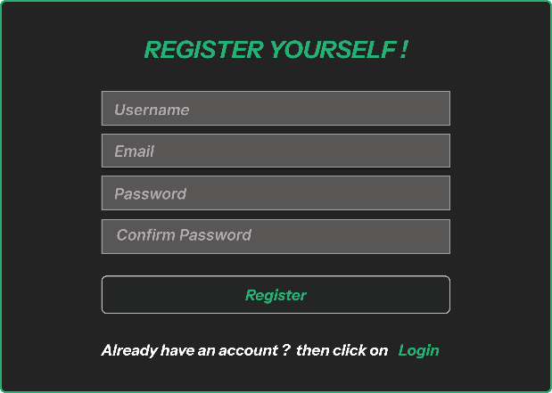
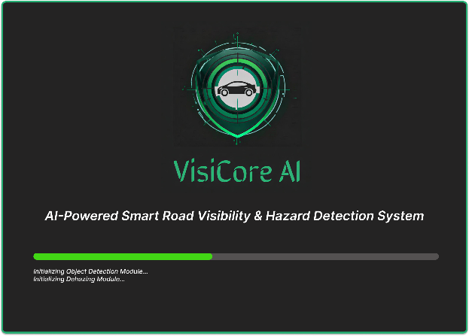
Screen Images:
Figure 4: Registration page
Figure 5: Splash Page
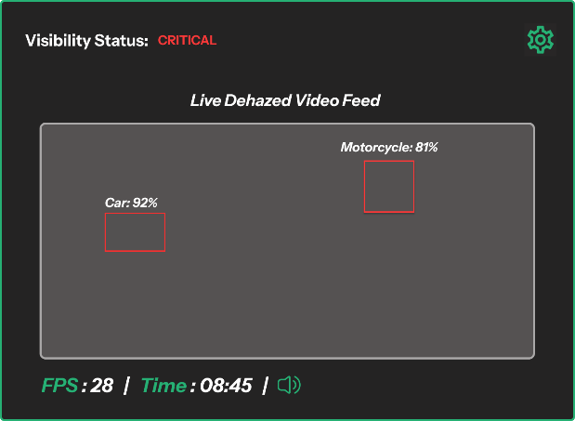
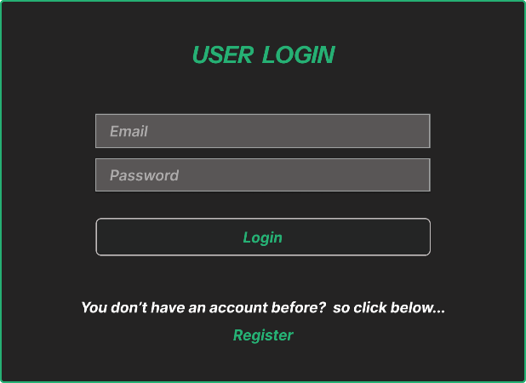
Figure 6: Main Page
Figure 7: Login Page
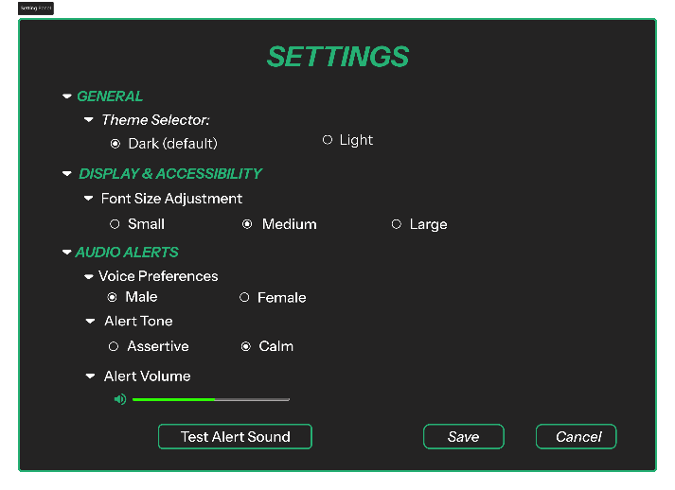
Figure 8: Setting Page

Screen Objects and Actions:
Screen Name | UI Object | Trigger / Action | System Response
Splash Screen | Progress Bar | Automatic (system-driven) | Displays system initialization and module loading status
Registration Screen | Register Button | User clicks register | System validates input and creates a new user record in the database
Registration Screen | Input Fields (Username, Email, Password) | User enters data | System captures and validates user input
Login Screen | Login Button | User clicks login button | System authenticates user credentials using the Authentication Module
Main Dashboard | Video Feed | Automatic (system-driven) | Displays real-time dehazed video stream
Main Dashboard | Visibility Status Indicator | Automatic update | Updates visibility level as Good, Moderate, or Critical
Main Dashboard | Bounding Boxes | Automatic detection | Highlights detected hazards with confidence scores
Main Dashboard | Audio Alert Icon | System/User action | Plays audio alert when critical condition is detected
Settings Panel | Alert Volume Slider | User adjusts slider | Updates audio alert volume level
Settings Panel | Save Button | User clicks save | Stores user preferences using the Settings Manager

Table 7:Screen Objects and Actions

Behavioral Model:

Interaction Diagram:
These models describe the dynamic behavior and event-handling processes of the system.
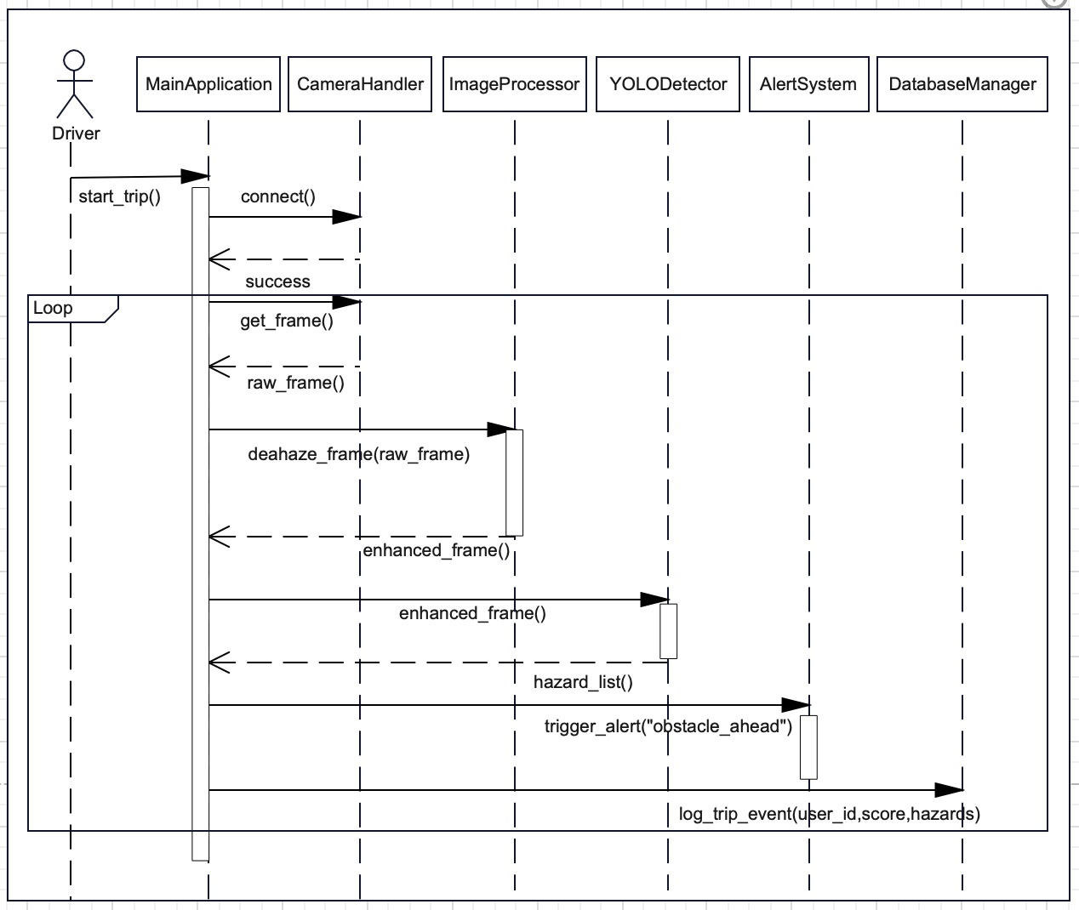

Figure 9: Interaction Diagarm

Description:
This diagram illustrates the real-time processing loop required for driver safety. The MainApplication requests a frame from the CameraHandler, which is then enhanced by the ImageProcessor. The YOLODetector analyzes the enhanced frame to return a hazard list, which triggers the AlertSystem if necessary. This entire sequence is optimized to execute in <200ms.

State Transition Diagaram:
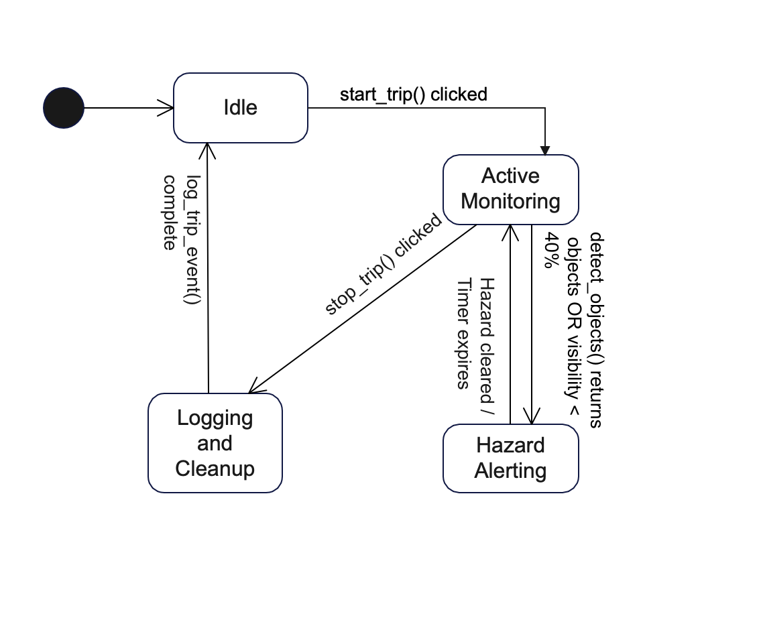
Figure 10: State Diagram

Description:

The State Transition Diagram models the system's reaction to environmental events. The system transitions from Active Monitoring to Hazard Alerting when the VisibilityEstimator reports a score below 40% (Critical) or the YOLODetector identifies an obstacle. Upon ending the trip, the system enters a logging state to save data via the DatabaseManager before returning to Idle.

Design Decisions:

Selection of AI Architecture: YOLOv8 Nano
The following design decisions were made to ensure the system meets the critical safety requirements of low latency, offline availability, and high accuracy in smog conditions.

- Decision:
The system utilizes the YOLOv8 Nano (yolov8n) architecture rather than larger models (YOLOv8-Medium/Large) or older frameworks like SSD or Faster R-CNN.
- Justification:
  - Real-Time Latency: The primary constraint is safety; the system must react instantly. The Nano model offers the fastest inference speed (~80 FPS on GPU, ~30 FPS on CPU), ensuring the system meets the 15–30 FPS requirement. Larger models would drop performance to <5 FPS on standard laptops, rendering the collision warning useless.
  - Resource Efficiency: The Nano model is lightweight (<4 million parameters) and quantizable, allowing it to run efficiently on standard consumer hardware without requiring expensive, dedicated GPUs.

Database Selection: SQLite
- Decision:
We selected SQLite as the database engine instead of client-server databases like MySQL or PostgreSQL.
- Justification:
  - Local Persistence: The application is designed as a standalone desktop tool. SQLite is serverless and self-contained, meaning the driver does not need to install or configure a database server to use the app.
  - Fail-Safe Reliability: Storing data in a local .db file ensures that trip logging continues seamlessly even if the laptop loses internet connectivity, which is critical for road reliability in remote areas.

Visibility Algorithm: Contrast-Based Analysis
- Decision:
We chose a Dark Channel Prior (DCP) & Contrast algorithm for visibility scoring instead of Monocular Depth Estimation.
- Justification:
  - Computational Load: Depth estimation using deep learning is computationally expensive. By using contrast analysis (a mathematical operation on the image histogram), we save system resources for the critical YOLOv8 hazard detection.
  - Smog Specificity: In dense smog, geometric depth cues are often lost. Contrast degradation is a more reliable and direct indicator of atmospheric visibility levels than geometric depth in these specific environmental conditions.

Selection of Programming Language: Python
- Decision:
We selected Python (3.8+) as the primary development language over C++ or Java.
- Justification:
  - Library Ecosystem: Python provides the most robust support for AI and Computer Vision libraries (PyTorch, Ultralytics, OpenCV, NumPy). Using C++ would require complex binding configurations that could delay development.
  - Rapid Prototyping: Python’s concise syntax allows for faster iteration and debugging of the visibility algorithms compared to compiled languages, which is essential for meeting the project timeline.

Deployment Architecture: Standalone Desktop Application
- Decision:
The system is designed as a Desktop Application (running on a laptop) rather than a Mobile App or Cloud-based Web App.
- Justification:
  - Processing Power: Real-time object detection (YOLOv8) requires significant CPU/GPU resources that standard smartphones cannot sustain without overheating or severe battery drain. A laptop provides the necessary thermal headroom and processing power.
  - Latency Elimination: A Cloud-based approach (sending video to a server) would introduce network latency, making the system unsafe for a moving vehicle. Local desktop processing guarantees the <200ms latency requirement.

Summary:
This Software Design Specification translates the functional and non-functional requirements into a structured and modular system design. The proposed layered architecture ensures scalability, real-time performance, and safety compliance. By leveraging lightweight AI models, local data persistence, and a minimal user interface, the system achieves reliable hazard detection and visibility monitoring suitable for real-world driving conditions.

References:
- Ultralytics YOLOv8 Documentation
- OpenCV Computer Vision Library
- SQLite Official Documentation
- ISO 25010 Software Quality Model
- IEEE 830 / 1016 Software Design Standards

